R. Reports Menu: 8. Reference Book Index

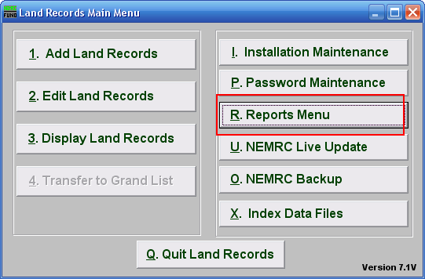
Click on “R. Reports Menu” from the Main Menu and the following window will appear:

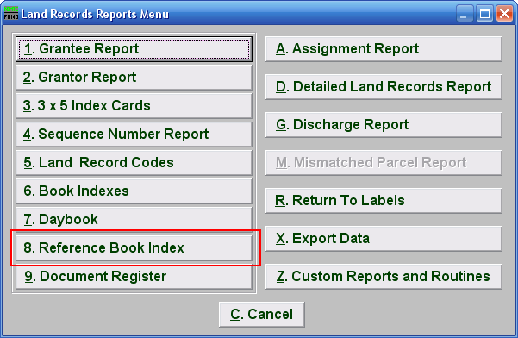
Click on “8. Reference Book Index” from the Reports Menu and the following window will appear:
Reference Book Index

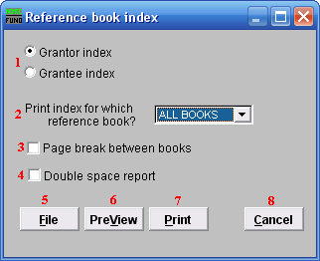

- Grantor index OR Grantee index: Select which index listing you are printing.

- Print index for which reference book?: Select the option from the drop down menu for which you are creating the index report.

- Page break between books: Check this box to have the system start each book on a new page when reporting.

- Double space report: Click this box to have this report be double-spaced instead of single-spaced. This is for marking up or visual appearance.

- File: Click this button to save this report on this computer. Refer to GENERAL FILE for more information.

- PreView: Click this button to preview this report. Refer to GENERAL PREVIEW for more information.

- Cancel: Click “Cancel” to cancel and return to the previous screen.

